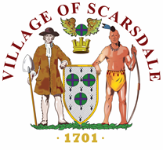 Village of Scarsdale

VILLAGE HALL / 1001 POST ROAD / SCARSDALE, NY 10583
914.722.1110 / WWW.SCARSDALE.COM

PRESS RELEASE

For Immediate Release 10.23.19
Contact: Captain Edward Murphy, Scarsdale Police Department
(914) 722-1200

WESTCHESTER COUNTY DEPARTMENT OF PUBLIC WORKS
TRAFFIC ADVISORY
HEATHCOTE BYPASS, C.R.143
VILLAGE OF SCARSDALE
SINGLE LANE CLOSURE

ROADWAY: Heathcote Bypass.

LIMITS: Between Weaver Street and Secor Road.

WHAT: Roadway repairs.

IMPACTS: The Heathcote Bypass will be reduced to a single lane of alternating traffic controlled by flag persons within the above limits.

WHEN: Thursday, October 24 and Friday, October 25, 2019 between the hours of
9:00 AM and 3:00 PM.

WHO: Westchester County Department of Public Works & Transportation

For additional information please contact Westchester County Traffic Engineering Division at 914-995-2555.

# # #

